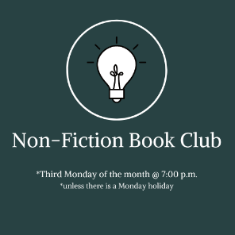**Non-Fiction Book Discussion Group   
Titles & Schedule for 2025  
Third Monday of the Month @ 7:00 p.m.  
*unless there is a Monday holiday**

January 27, 2025

***Becoming Earth: How Our Planet Came to Life* by Ferris Jabr**c. 2024; 304 pages

February 24, 2025  
***The Wager: A Tale of Shipwreck, Mutiny and Murder* by David Grann**  
c. 2023; 329 pages

March 17, 2025  
***Botany of Desire: A Plant’s Eye View of the World* by Michael Pollan**  
 c. 2001; 271 pages

April 21, 2025  
***Ben & Me: In Search of a Founder’s Formula for a Long and Useful Life* by Eric Weiner**  
c. 2024; 336 pages

May 19, 2025  
***The Best Minds: A Story of Friendship, Madness, and the Tragedy of Good Intentions* by Jonathan Rosen**  
c. 2023; 576 pages

June 16, 2025  
***The Anxious Generation: How the Great Rewiring of Childhood is Causing an Epidemic of Mental Illness* by Jonathan Haidt**c. 2024; 400 pages

July 21, 2025  
***A Walk in the Park: The True Story of a Spectacular Misadventure in the Grand Canyon* by Kevin Fedarko**c. 2024; 505 pages

August 18, 2025  
***Atomic Habits: An Easy & Proven Way to Build Good Habits & Break Bad One* by James Clear**  
c. 2018; 320 pages

September 15, 2025  
***Educated: A Memoir* by Tara Westover**  
c. 2018; 368 pages

October 20, 2025  
***The Secret History of Bigfoot: Field Notes on an American Monster* by John O’Connor**  
c. 2024; 304 pages

November 17, 2025  
***The Boys of Riverside: A Deaf Football Team and a Quest for Glory* by Thomas Fuller**  
c. 2024; 256 pages

December 15, 2025  
***Frostbite: How Refrigeration Changed Our Food***c. 2017; 221 pages